Business Consulting – BM Website page


“The things we fear most in organizations including fluctuations, disturbances, imbalances, are the primary sources of creativity.” - Margaret J. Wheatley
Get in Touch
At BlewMinds, Consulting goes beyond the conventional realm of advice-giving. We see it as a powerful catalyst for evolution, sparking passion, & driving meaningful change. Our Business Consulting services delve deep into the heart of your organization, harmonizing with the Vision & Values to create internal as well as external growth.
At BlewMinds, Consulting goes beyond the conventional realm of advice-giving. We see it as a powerful catalyst for evolution, sparking passion, & driving meaningful change. Our Consulting services delve deep into the hearts of individuals & organizations, harmonizing with your vision & values to create internal as well as external growth.
We believe in the power of human potential. Our mission is to amplify it, guiding you through a journey of self-discovery & organizational excellence. It is about igniting the spark within your team, creating a ripple effect of positive change that extends beyond your organization. Our Culture at BlewMinds is more than just words on a wall. It is about making a difference to our community by embodying values of openness, agility, intelligence, directness, & authenticity.
Our Consulting approach is anchored in psychology-driven practices integrated with the analysis of human behavior. We immerse ourselves in the core of our clients' organization, gaining a deep understanding of the unique dynamics & aspirations that propel our client forward. We believe in the power of empathy & significance of understanding the human element within every organization.
Our Areas of Consulting
Business Consulting:


Business Consulting for us is all about helping organizations from x to 100x or more. It is about getting them to scale, transform & grow through their Human Capital renewal. We provide management as well as simplistic business consulting services to help organizations improve performance, efficacy & efficiency. We help businesses analyze their systems & practices to create sustainable solutions for their business problems, all this with a firm eye on being human, practical, authentic & real. We help clients meet their Big, Audacious Goals by providing a new perspective as effective Change catalysts for their companies.

HR Consulting:


At BlewMinds, we excel in delivering a comprehensive suite of services, from Human Resources & Performance Management to Talent Consulting, Leadership Consulting, People Analytics & Data Visualization. We offer comprehensive Descriptive, Predictive, & Prescriptive Analytics services in Human Resources. Creating compelling employee experiences, from hiring to exits, we ensure seamless alignment with your organizational culture & values.

At BlewMinds, we excel in delivering a comprehensive suite of services, from Human Resources (HR) & Performance Management to Talent Consulting, Leadership Consulting, Customer Analytics & Data Visualization. We offer comprehensive holistic Descriptive, Predictive, & Prescriptive Analytics services across various facets of Human Resources. Creating compelling employee experiences, from hiring to exits, we ensure seamless alignment with your organizational culture & values. Our HR consulting Services domain includes:

- Culture Consulting
- Human Resources Strategy Consulting
- Human Resources Process Consulting
- Talent Management Consulting

Management Consulting:


We consult across B2B, B2C & B2E markets working as Partners for small enterprises, large organizations & also universities across the Globe. We delve into client requirements pivotal for iconic management of organizational culture & expectations.
Furthermore, we align the client’s organizational goals towards the right problem solutioning. As we aim to bridge gaps between client problems & solutions, we partner with our clients to help them smoothly implement these solutions to create continual win-win business situations.

We consult across B2B, B2C & B2E markets working as Partners for small enterprises, large organizations & also universities across the Globe. We delve into client requirements pivotal for iconic management of organizational culture & expectations. Furthermore, we align the client’s organizational goals towards the right problem solutioning. We partner with our clients to help them smoothly implement these solutions to create continual win-win business situations. Our comprehensive Management Consulting domain includes:

- Operations Consulting
- Process Improvement Consulting
- Financial Planning & Analysis Consulting
- Innovation Strategy Consulting
Talent Consulting: We work in the space of individual & organizational transformation. Our interventions cover end-to-end aspects of Talent Consulting with a dash of StoryTelling. We have enabled clients to work on 3 clear Talent areas of self, team & business. Our eclectic Talent Consulting work travels the entire gamut of Human Resources (HR) with a focus on Capability Development, Competency Management, Employee Engagement, HR Advisory, HR Strategy, People Assessments, Talent Management & Talent Transformation.

Technology Consulting:


Technology has rapidly shifted from being a cost function to a vital competitive advantage for organizations. Harnessing the power of technology & digitization to drive business strategy provides a significant edge in any industry.
Hence, our Technology Consulting Services focus on four key areas that challenge organizations of all sizes, from humble bright startups to established enterprises:

Technology has rapidly shifted from being a cost function to a vital competitive advantage for organizations. Harnessing the power of technology & digitization to drive business strategy provides a significant edge in any industry. Hence, our technology consulting services focus on four key areas that challenge organizations of all sizes, from humble bright startups to established enterprises. Our Advanced Technology Consulting domains include:

- CIO/CTO Function Outsourcing
- Digital Transformation Advisory
- Software Services
- Technology Strategy Advisory

Marketing Consulting:


Elevate your brand with our all-encompassing marketing services. We craft emotive strategies that resonate with your audience, from influencer campaigns to market research & social media marketing, amplifying a brand's presence & impact. Our services include:
- Content Creation
- Influencer Marketing & Social Media Marketing
- Market Research & Marketing Analytics
- StoryTelling
- Website/Social Media Analytics
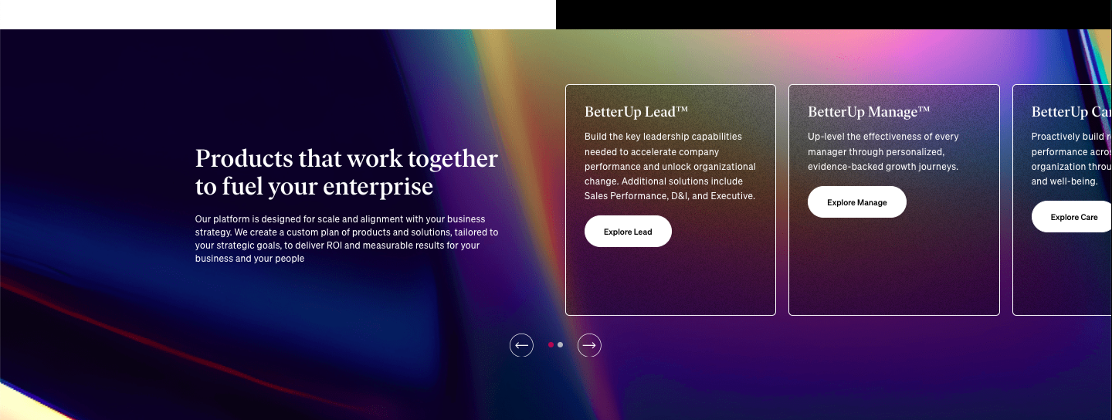

Get in Touch

Why BlewMinds?

Across our different domains of Consulting, at BlewMinds, we incorporate powerful frameworks including the 5-Factor Framework, Hofstede's Culture Matrix, Bullseye Framework, Porter’s 5 Forces Model & PPP Model of Agile Transformation to guide our Consulting processes. These frameworks enable us to provide deep scientific insights to our clients & tailor strategies that foster meaningful change & growth in organizations.
By integrating these frameworks into our Consulting practice, we ensure a holistic & comprehensive approach to organizational transformation. This enables us to understand organizational strengths, areas for improvement as well as develop tailored strategies aligned with our clients’ unique culture & business objectives. We drive sustainable change by addressing both the technical & emotional aspects of transformation, optimizing leadership, processes, people & technology to achieve exceptional results.
Get in Touch

Benefits of choosing BlewMinds Consulting Services
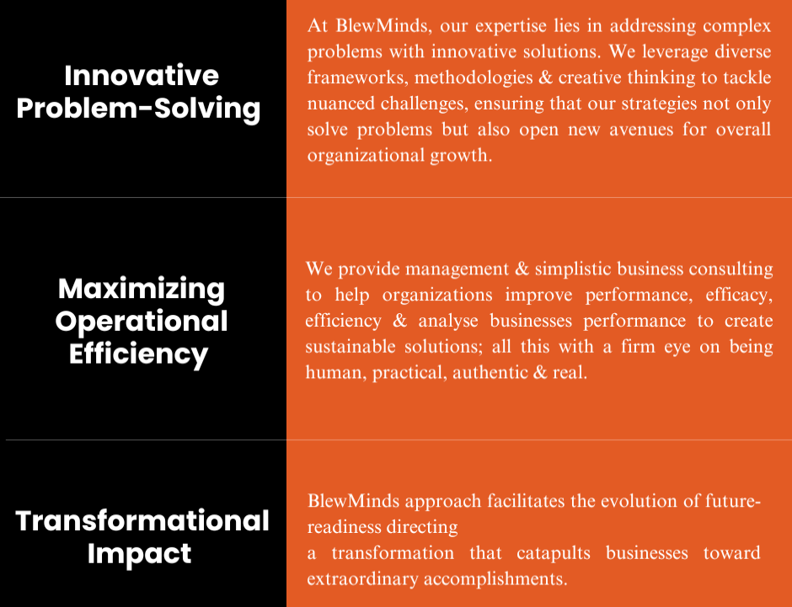

Let us discuss your consulting needs – Form

FAQs

Q1: Why would I/my company need a Consulting firm?
A: Many of our clients encounter obstacles that inhibit growth & profitability, face challenges in scaling their business or developing growth plans that deliver results, & experience inefficiencies due to outdated business processes. At BlewMinds, we provide simple, practical, future-forward & commercially viable solutions to address these issues, enabling seamless operations, improved performance, & sustainable growth.

Q2: Do we really need a Business Plan?
A: Yes, a well-crafted Business plan is crucial for long-term growth & innovation. It helps identify potential opportunities, pitfalls & provides a roadmap for scaling, transforming your business while also ensuring alignment with market strategies, financial goals, & operational efficiency.

Q3: Why should we hire a Consultant to write our Business Plan instead of doing it ourselves?
A: A Consultant acts as a mentor to guide your business journey. We facilitate brainstorming & idea generation, assist in problem resolution, instill a sense of accountability, boost motivation among employees & serve as a sounding board for your critical decisions. Additionally, as a consultant we also aid in strategizing & developing effective plans, helping you navigate challenges & drive your business forward.

Q4: What can you expect from having BlewMinds as your Consulting Partner?
A: With BlewMinds as a Consulting Partner, clients can expect active listening, a deep understanding of existing problems, customized real time solutions based on detailed analysis & understanding of the client’s organizational needs. You will be offered practical guidance & strategic insights to improve performance, profitability, & address business challenges effectively.

Q5: Why should we choose BlewMinds Consulting Services?
A: Choosing BlewMinds means partnering with a Global Consulting firm that blends eclectic experience with subject matter expertise to provide practical & viable solutions. We excel in understanding the unique culture, goals & values of your organization, offering tailored guidance that drives sustainable growth. Our passion for StoryTelling empowers you to communicate your Brand values impactfully. Additionally, we apply research-based frameworks & extensive IT experience to unlock business value & transform operations. With a human-centric approach, we ensure authenticity, practicality, & real impact in every engagement.
Additionally, we unlock business value & drive operational transformation with our human-centric approach that ensures each engagement is authentic, practical & delivers meaningful results.

Keywords: Business Consulting | Comprehensive management consulting | HR Consulting Services | HR Consulting Services | Management Consulting
Focus: Business Consulting
Meta Description: At BlewMinds, Business Consulting is an approach that drives business value & operational transformation. Learn more.

